University of Florida
Levin College of Law

Florida Civil Procedure
Course 6303 3-credits

Course Syllabus

Course: Florida Civil Procedure
Spring Semester 2023

Class time: M, T, W 11:00 AM – 11:55 AM Room: HH 360

Physical Office Hours:

Monday and Tuesdays between 2:00 PM – 3:00 PM by appointment or any other day at a mutually agreeable time by appointment.

Virtual Office Hours:

By appointment. My Zoom address is https://ufl.zoom.us/j/4591597877 (Passcode EDISCO).

Course Description:

This course will provide a through introduction to the rules, statutes, cases and principles of Florida civil procedure. The course will emphasize concrete litigation problems and strategies. This course is essential for anyone anticipating a career that involves litigation in Florida courts. This course will give you a good feel for what it means to be a practicing litigator and how to hit the ground running when you start practicing.

Course Learning Objectives:

After completing this course, you will have obtained:

- Knowledge of the principal rules governing pretrial civil practice
- Knowledge of how to utilize the rules to obtain litigation goals.
- Knowledge of the relationship between Florida civil procedure rules and statutory requires governing civil procedure
- The structure and jurisdiction of Florida courts
- The Florida civil procedure rule making process.

Who Is Your Professor?

I joined the UF Law faculty after 30 years practicing complex civil litigation in state and federal courts with Holland & Knight in Miami and Tampa and with Quarles & Brady in Tampa. Prior to joining the faculty on a full-time basis, I had the privilege of teaching at UF Law as an adjunct professor for 10 years.

I earned a BA in philosophy from Lehigh University in Bethlehem, Pennsylvania, and an MA in philosophy from Washington University in St. Louis, Mo. I graduated from UF Law in 1983.

Here are a few links where you can learn more about me.

https://www.law.ufl.edu/faculty/william-hamilton
https://www.law.ufl.edu/areas-of-study/institutes/icair
https://www.linkedin.com/in/williamfhamilton
http://www.quarles.com/william-bill-hamilton/

I am married to Cindy Tejcek. Cindy graduated from Loyola in Chicago with a BS in mathematics. She holds an MBA from Kellogg School of Management at Northwestern University. We meet when she was the Chief Information Officer of the American Bar Association.

We have a son who is an Army captain.

We have another son who is a RN supervisor at Lakeland’s Memorial Hospital Emergency Department.

Our daughter is a sergeant with the Florida Department of Corrections.

How Can You Get In Touch with me?

I want to hear from you. Send me an email, call, or text.

Email | Telephone | Text | Office
hamiltonw@law.ufl.edu | 480.993.8777 | 480.993.8777 | HH 376

Please let me know If you have something to share with me – an inspiration, a new thought, a frustration, or concern.

Zoom is my videoconferencing tool. We can have a face-to-face video conference any time (even on tablets and smartphones).

Zoom | SKYPE
https://ufl.zoom.us/j/4591597877 | william.hamilton.1120

Teaching Philosophy and Instructional Methods: This course has a practical orientation. While you will learn the Florida Rules of Civil procedure, study applicable statutes, and read cases. The course emphasis is on solving the practical problems. We will have lots of class discussions, practical exercises, and periodic low stakes quizzes.

You may wish to review literature on experiential learning. My philosophy is in large part captured in Make It Stick: The Science of Successful Learning by Peter C. Brown.

In part, this course is designed to introduce students to a variety of career paths involving litigation. I recommend the book “Designing Your Life: How to Build a Well-Lived Joyful Life,” by Burnett and Evans, Alfred A. Knopf (2016), for helpful strategies to find career directions that will work for you.

Attendance: You are expected to attend all class sessions. Each class is worth 2 points. Each week you will be asked to read certain basic cases, statutes and text. At approximately every three weeks there will be an in-class 20-minute low stakes quiz to give you and me or some feedback on how we are doing. Each quiz is worth 30 points.

Is this Course Graded on a Curve?

This course is graded on a curve. I am provided a curved grade range by the Registrar and my class grades average must be within that range. In past semesters my curved average has been 3.35.

Course points may be earned as follows:

1. Final examination: 200 points.

The examination will be administered by the Registrar’s office. The examination will include materials and topics discussed in class in addition to the readings.

2. Class Attendance and Participation: 80 points (2 points per class).

Class attendance and participation is expected. Each class is worth 2 points.
Per ABA requirements, please attend all classes. Requirements for class attendance and make-up exams, assignments, and other work in this course are consistent with university policies that can be found at: https://catalog.ufl.edu/ugrad/current/regulations/info/attendance.aspx.

Class participation requires:

- Asking and answering questions that illuminate the issues,
- Asking and answering questions that enrich the class dialogue and advance the classes understanding of the issues,
- Participating in the class dialogue and discussions,
- Participation team debates and mock exercises,
- Engaging in class activities, exercises and projects.
- Demonstrating class preparation.

I recognize that you may have legitimate and compelling personal and professional requirements that may cause a class absence. If you will not be attending a class for personal or professional reasons, please notify me in advance as a professional courtesy. I will provide attendance points for students who notify me in advance of an absence. When you have not provided me with advanced notice, attendance points will be provided for missed classes on a showing of compelling circumstances excusing prior notification.
It is important that you are comfortable participating in class discussions and communicating with me on any issues related to the class. If your preferred name is not the name listed on the official UF roll, please let me know as soon as possible by e-mail or otherwise. Please let me know how you would like to be addressed in class, if your name and pronouns are not reflected by your UF-rostered name.​

3. Low Stakes Check-Ups: 120 points

There will be three 20-minute in class “check-ups” that will consist of multiple choice, true/false, and matching or short answer questions. Each of the checkups will be worth 40 points. The multiple-choice check-ups are designed to give you feedback and a reality check on how well you understand the course materials presented so far and to provide feedback to me on what course areas and topics may need additional coverage

Class Cancellations

Occasionally, I may have to reschedule a class due to professional demands. If this happens, I may record video lectures for the class to watch or conduct the class remotely by Zoom.

Are Smartphones and Laptops Permitted in the Classroom?

You may use laptops in class to take notes. Please restrict the use of your laptop to taking notes. Do not visit social media websites, texting, or emailing. Keep your browser closed to avoid temptation. Do not abuse this privilege. I expect your attention in class. Nothing life changing will happen while you are offline in class. I will randomly ask questions in class.

What Notes Should I Take in Class?

I recommended that you do not take “word-for-word” notes. This is not a court reporting class! Instead, think about what is happening in class and record the key ideas. Actually, handwriting your notes is better for you then typing notes. Check out this article: Note-Taking: Writing vs. Typing Notes. Beyond that, it is a good legal skill. You will need to learn to take good witness interview notes, deposition notes, and trial notes. A computer will not always be available or good to use.

Assigned Text:

In addition to selected cases, we will be using various LexisNexis Practice Guides and Trawick's Florida Practice & Procedure. All class resources are online and freely available to you.

Weekly Class Objectives, Schedule, and Assignments:

Week 1:
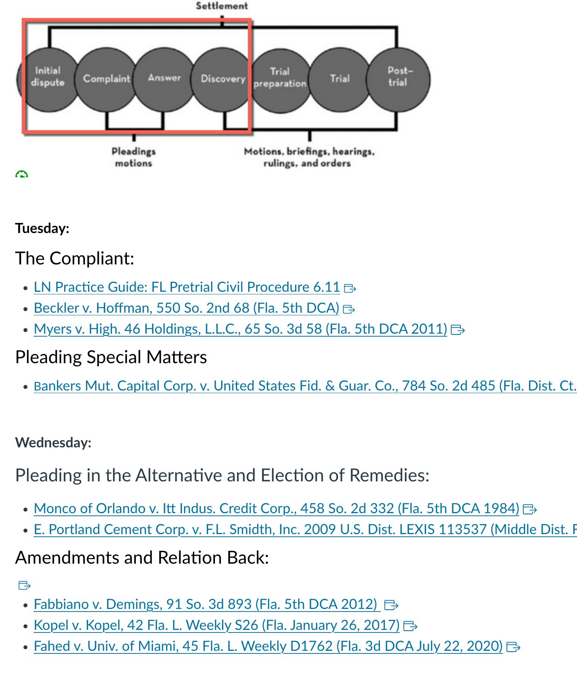

Week 2:
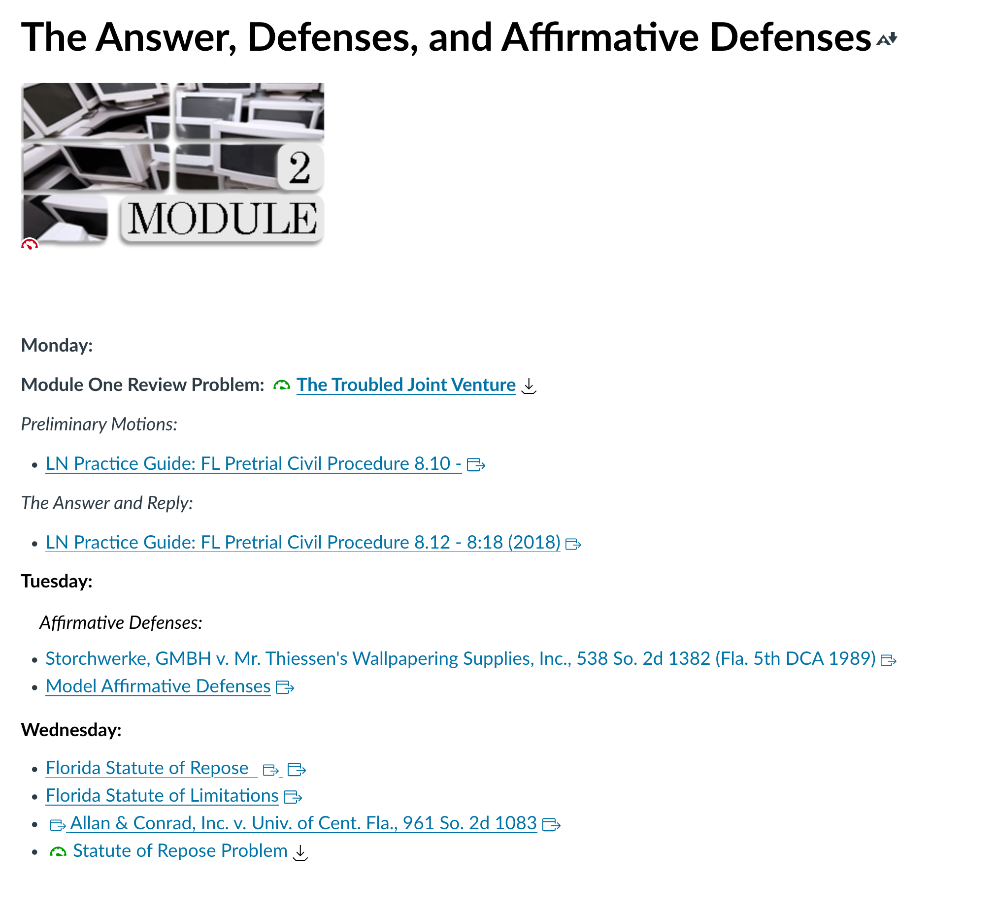

Week 3:
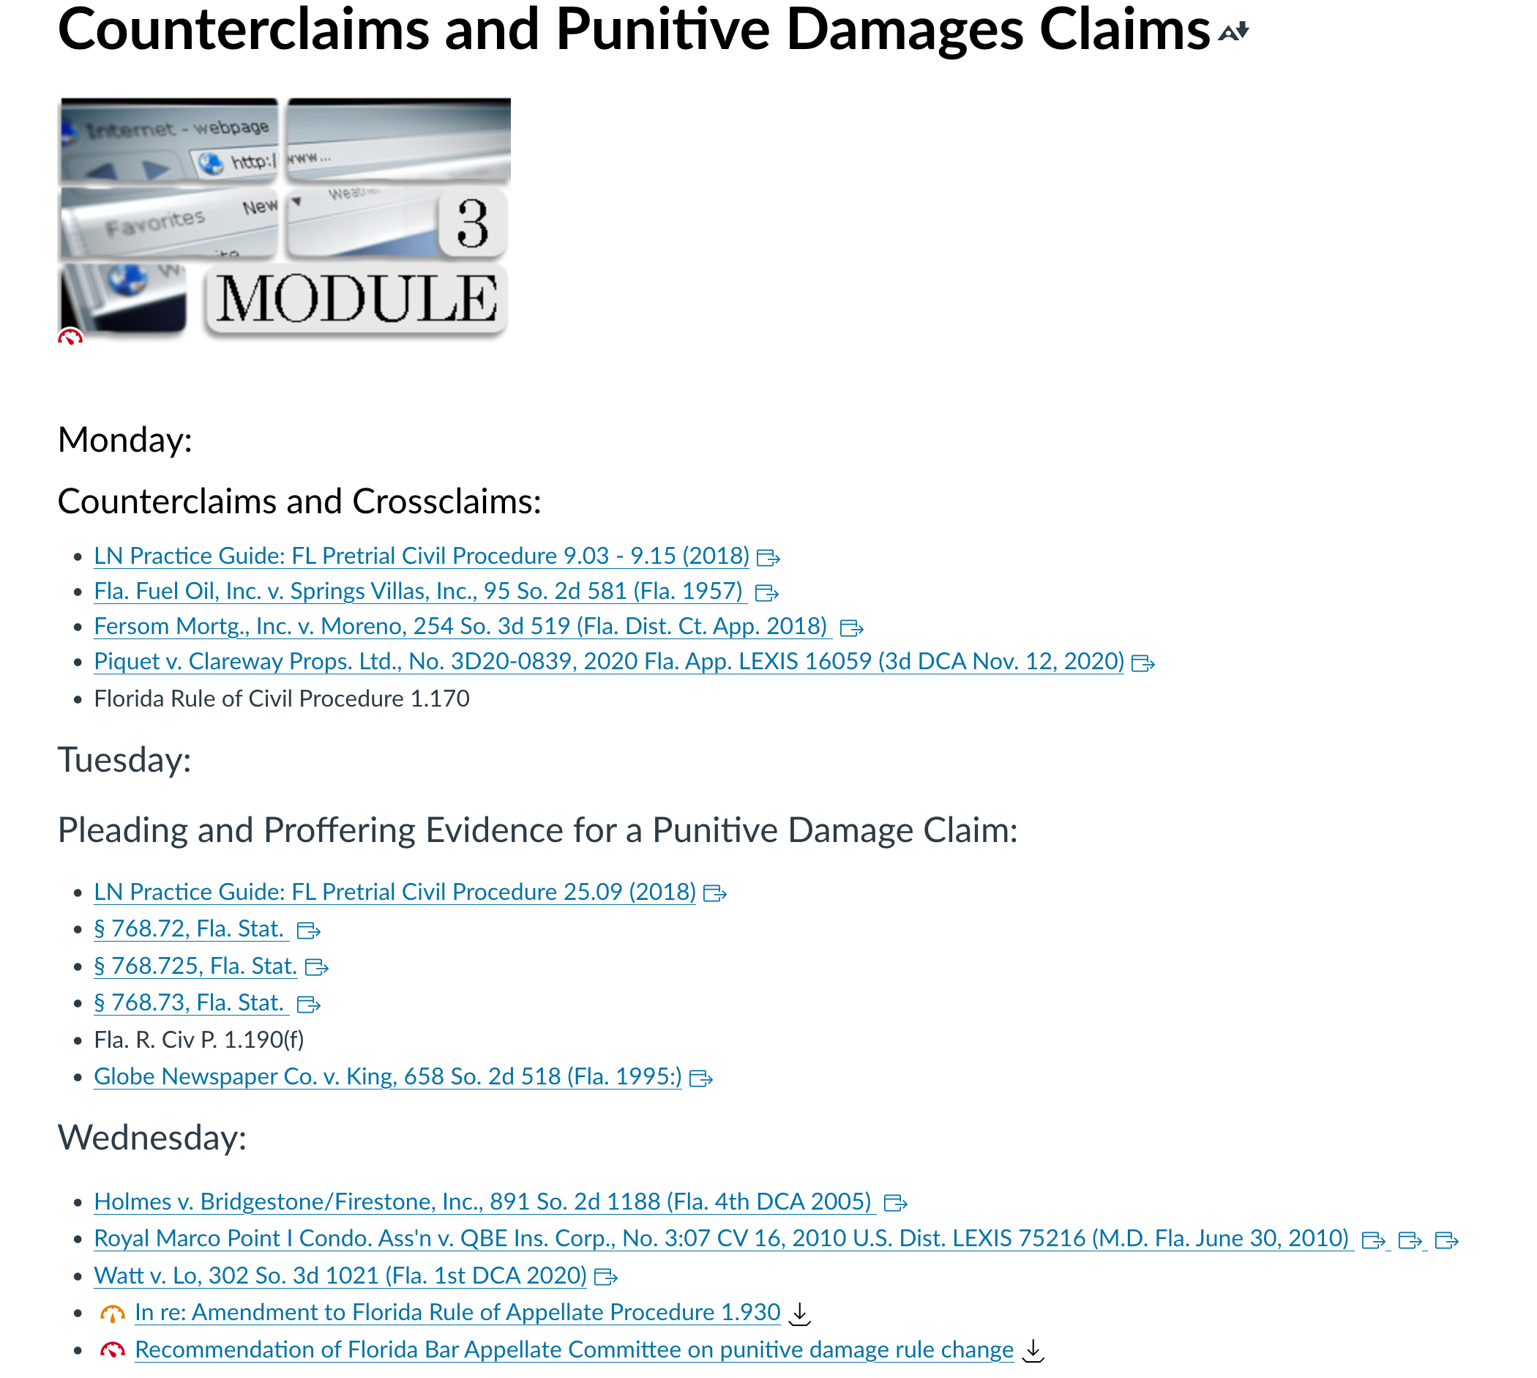

Week 4:
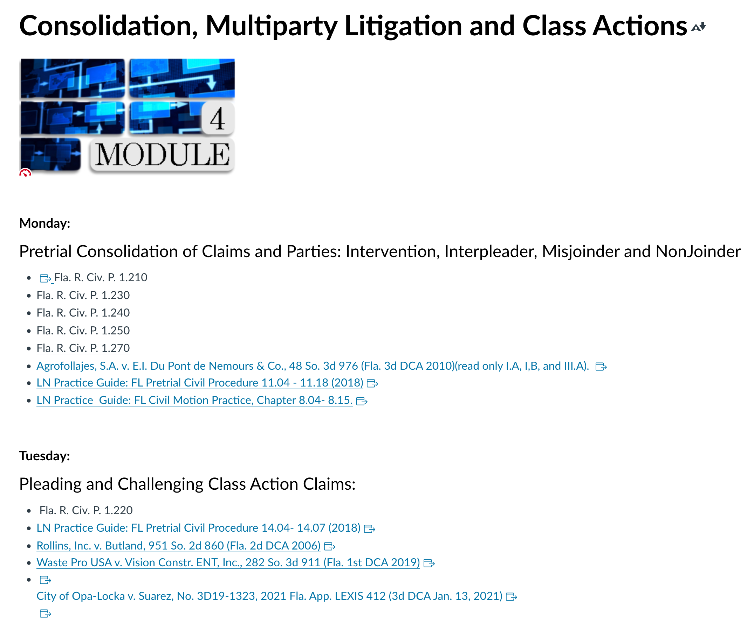

Week 5:

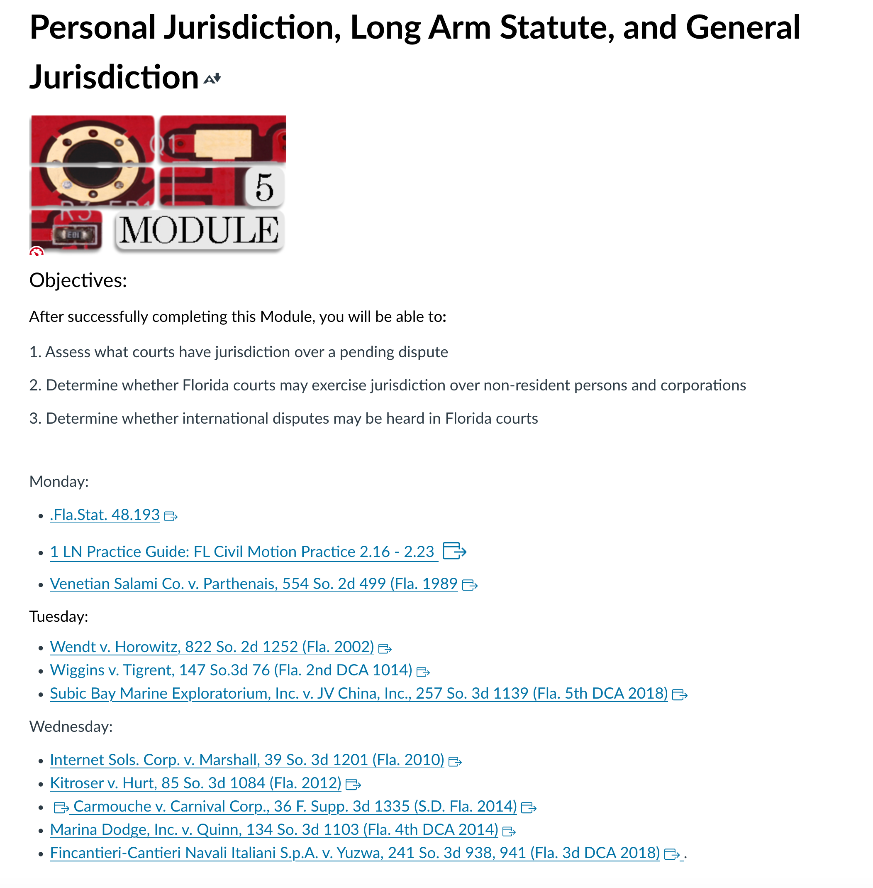

Week 6
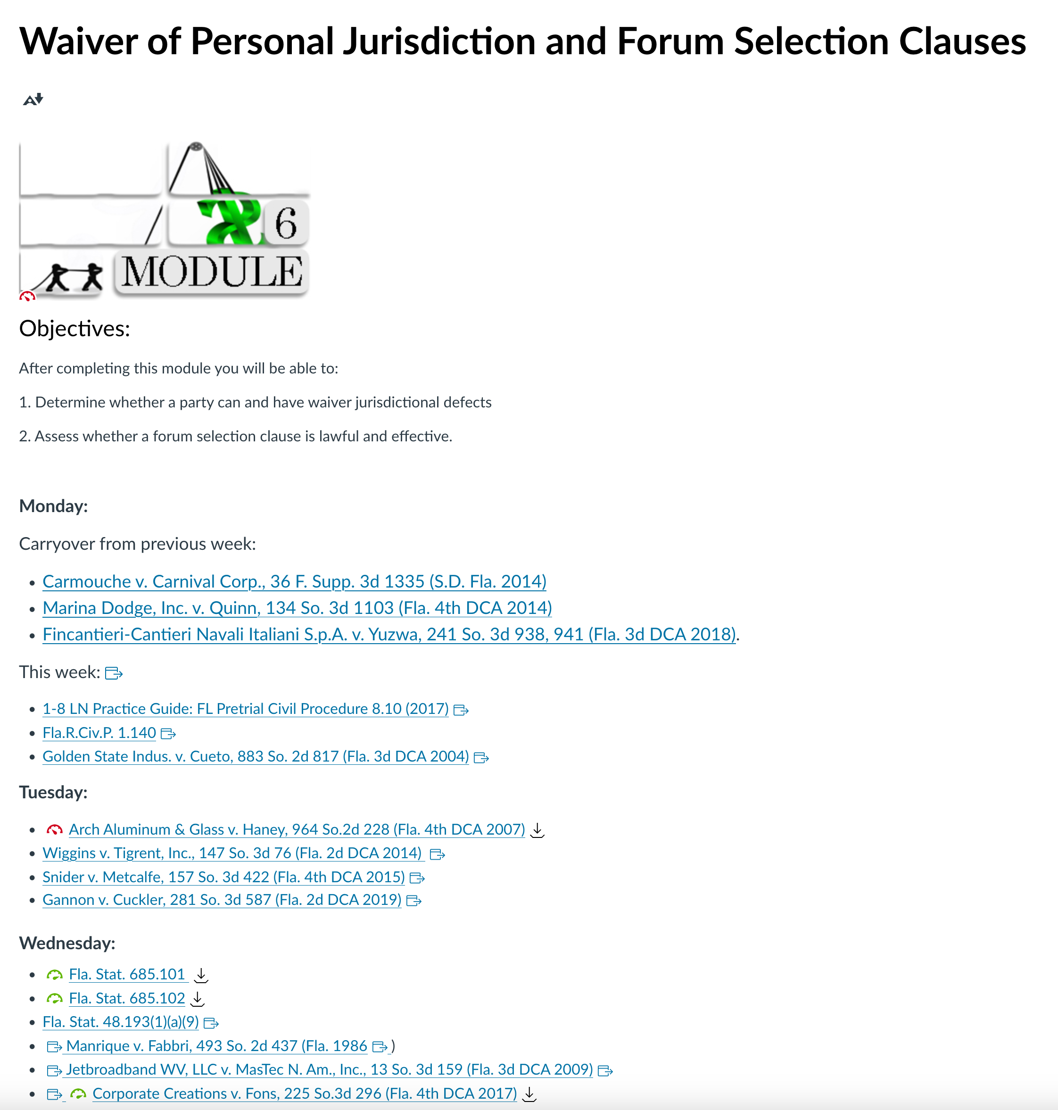

Week 7:
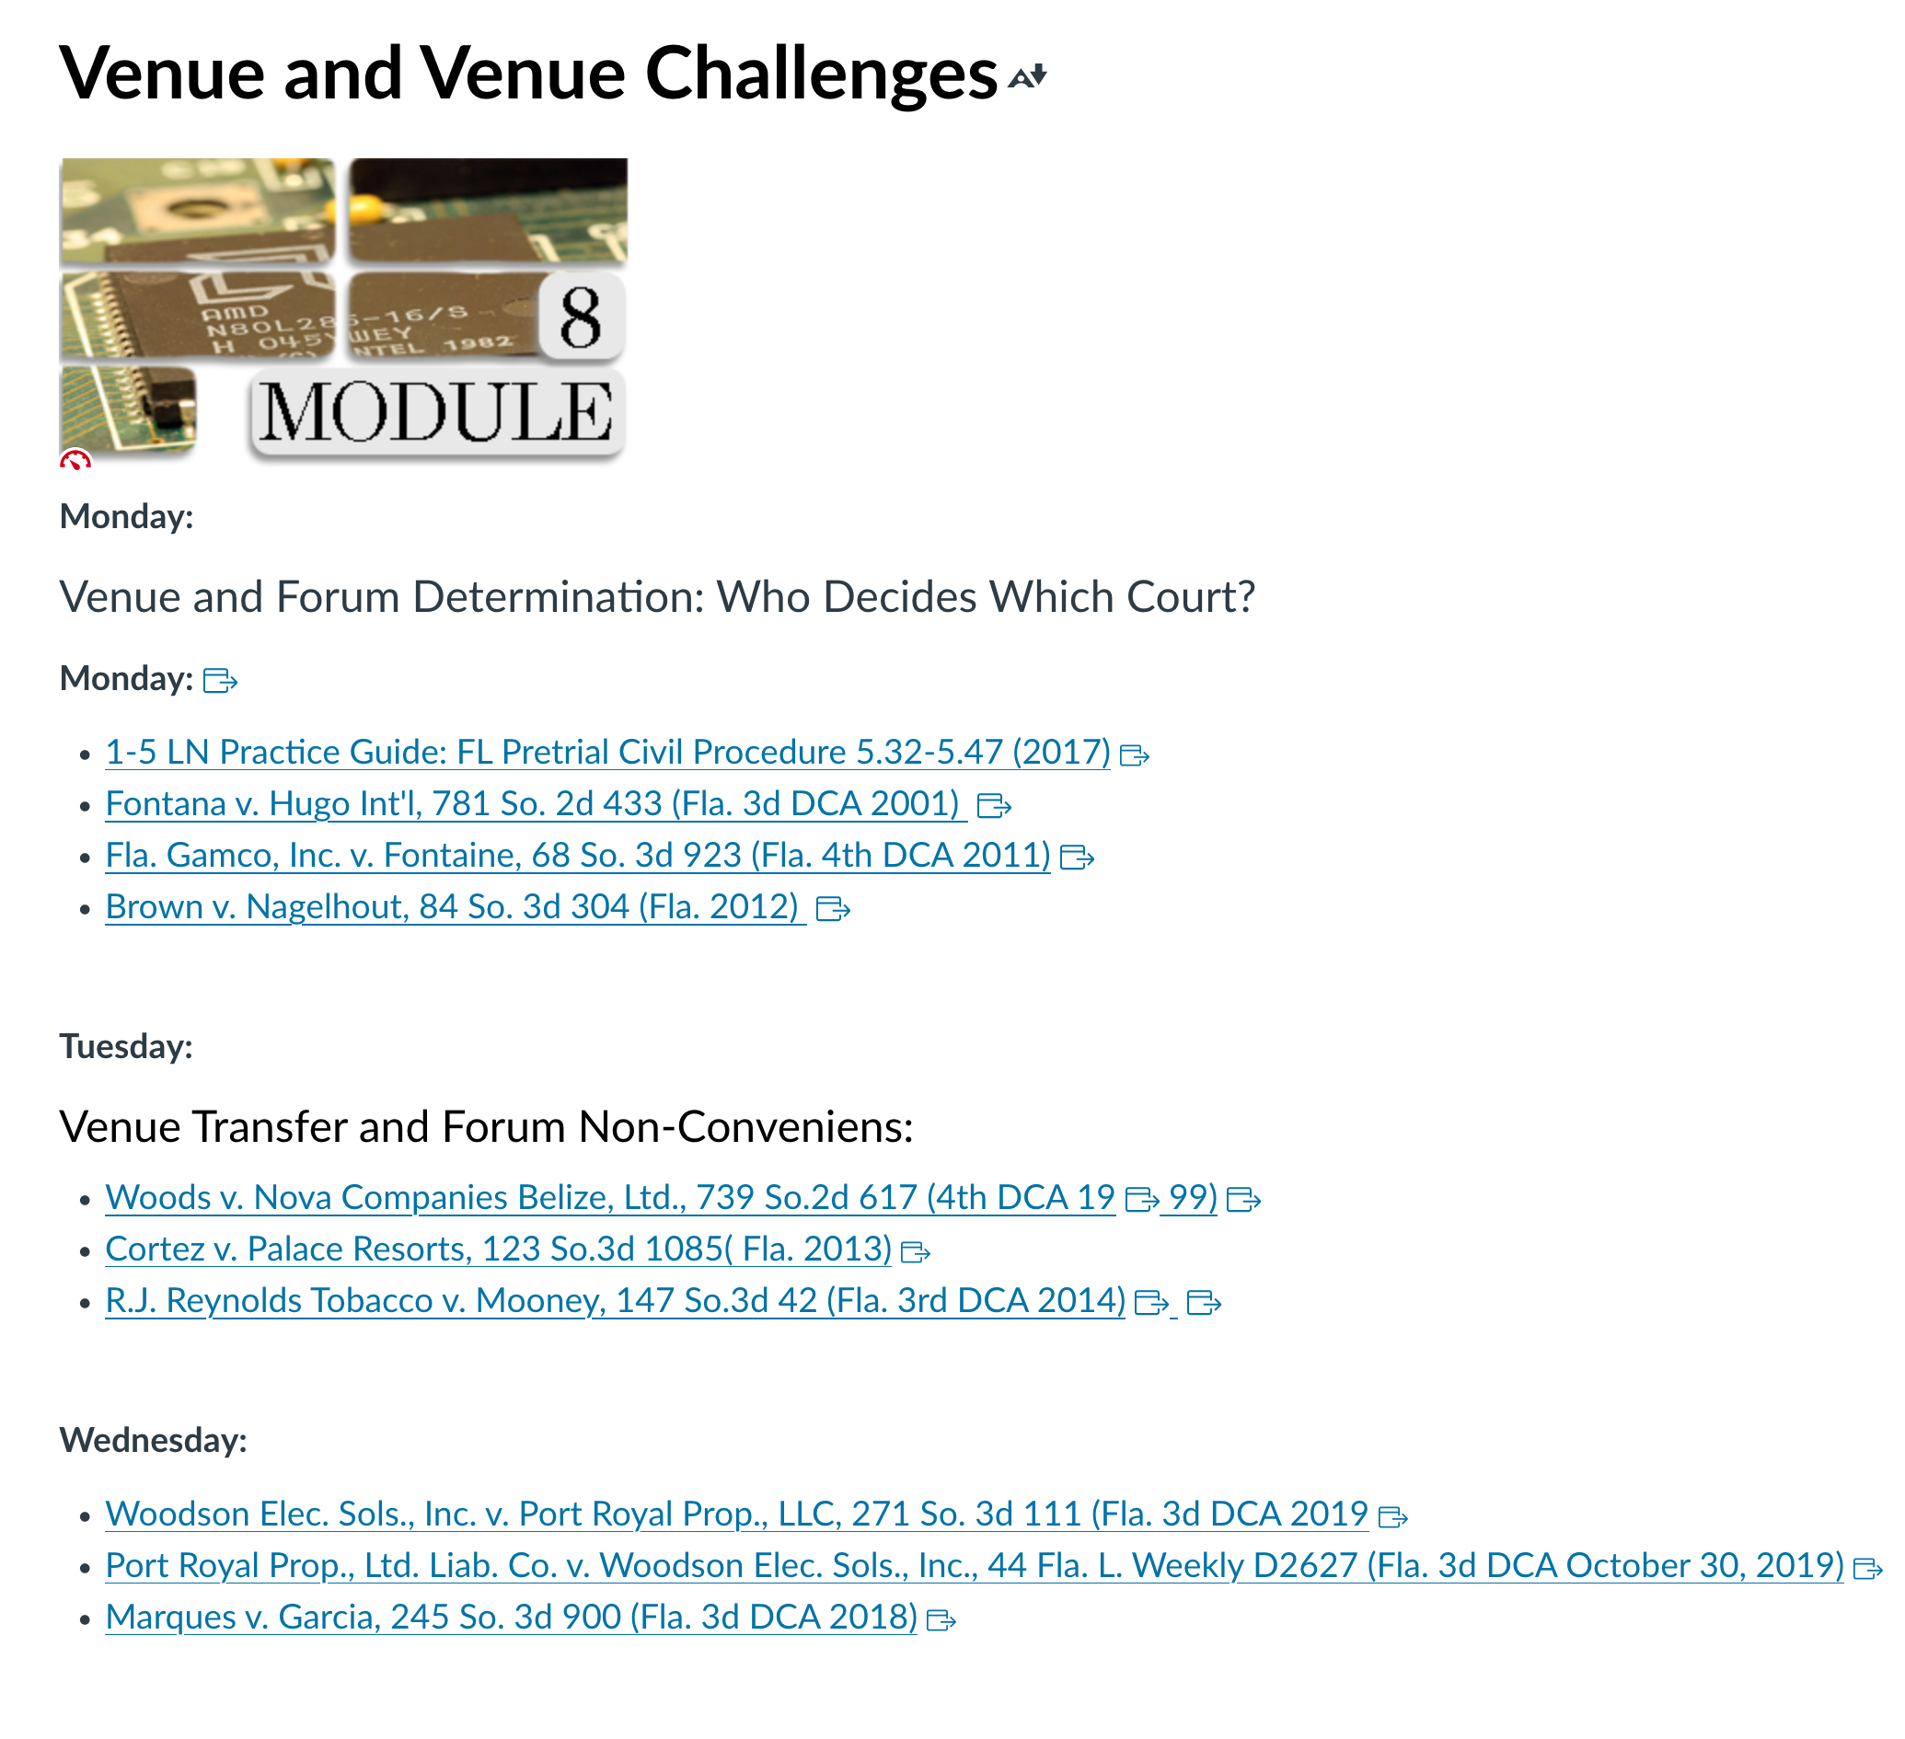

Week 8:
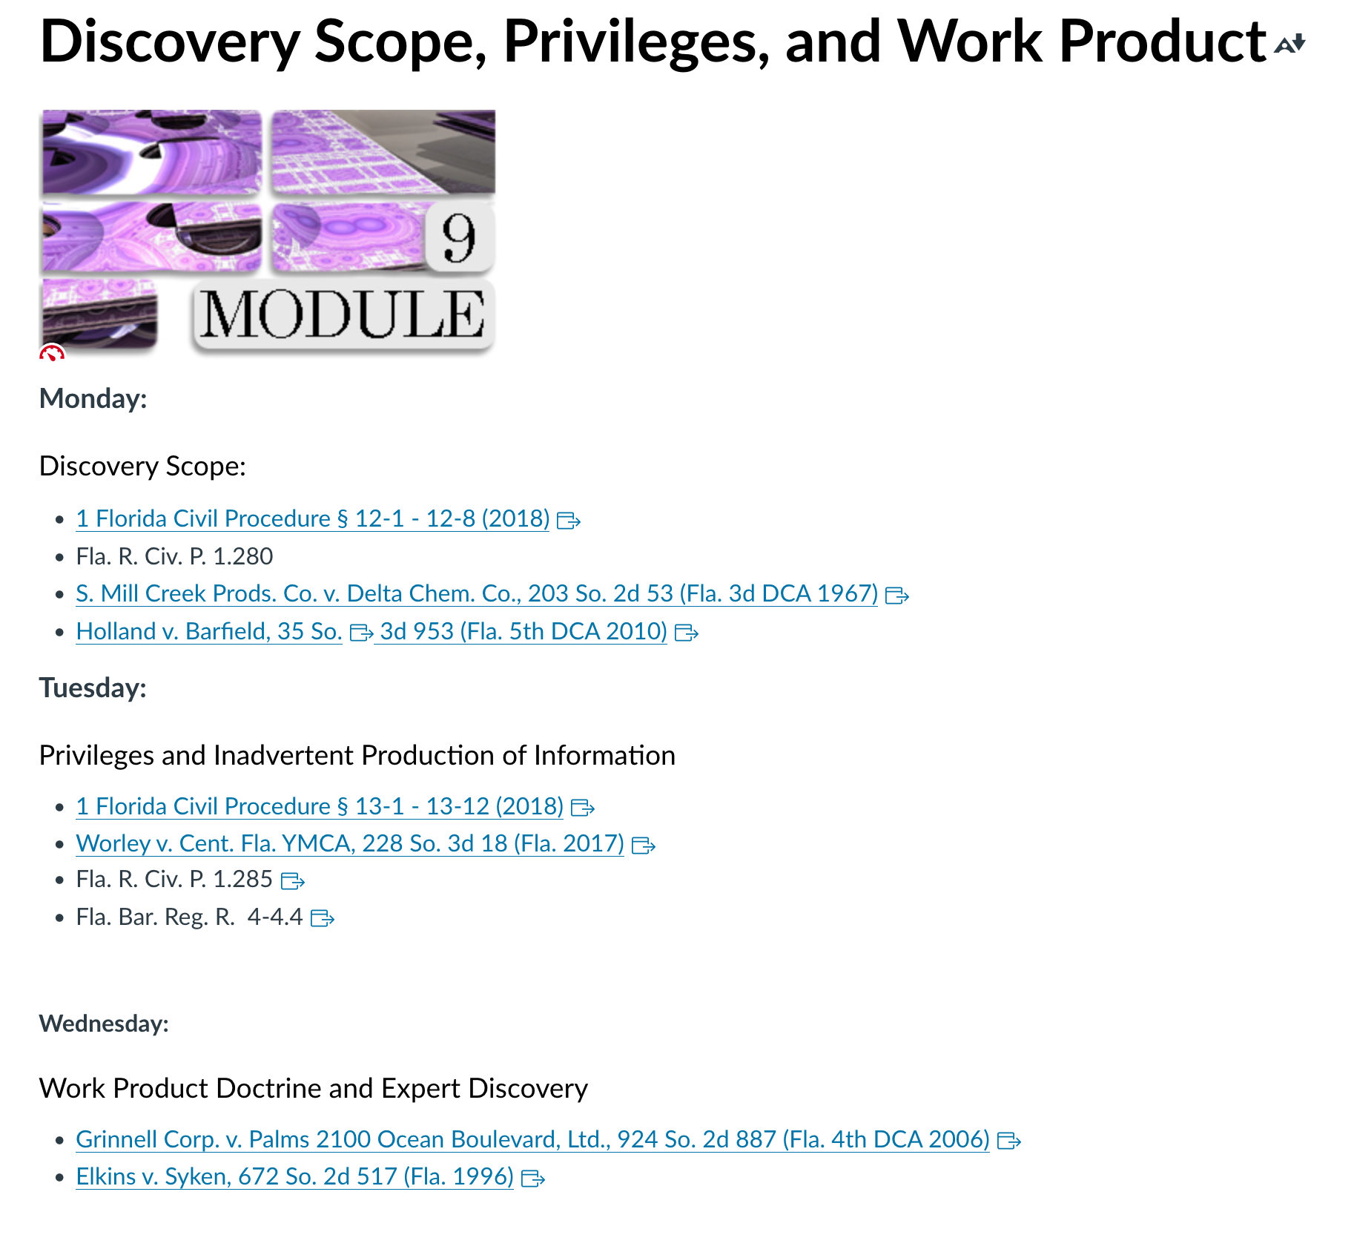

Week 9:
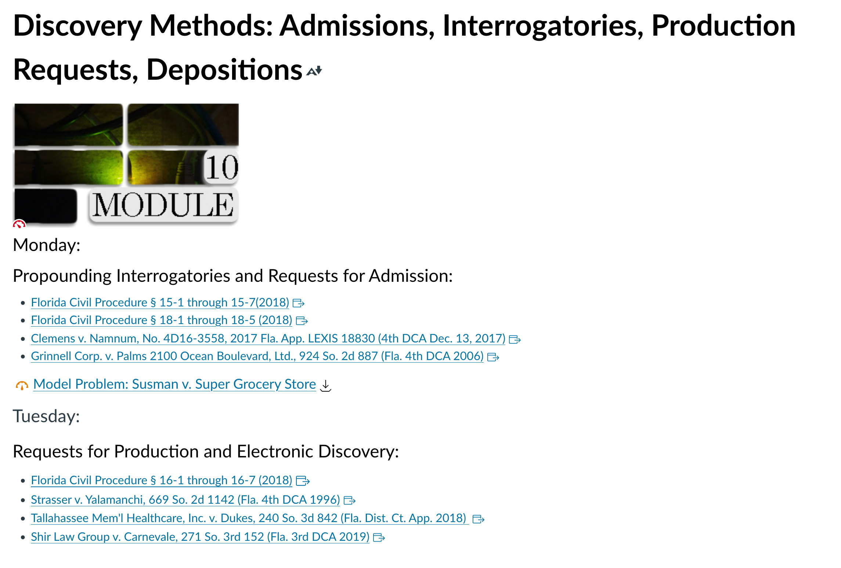

Week 10:
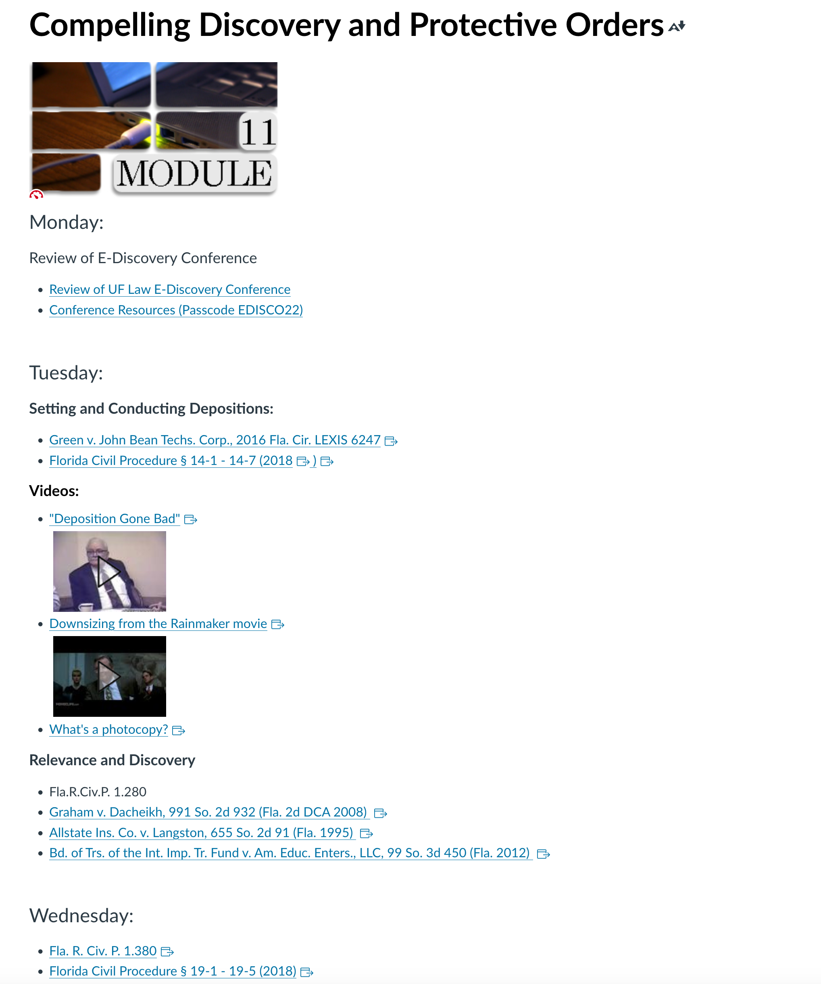

Week 11:
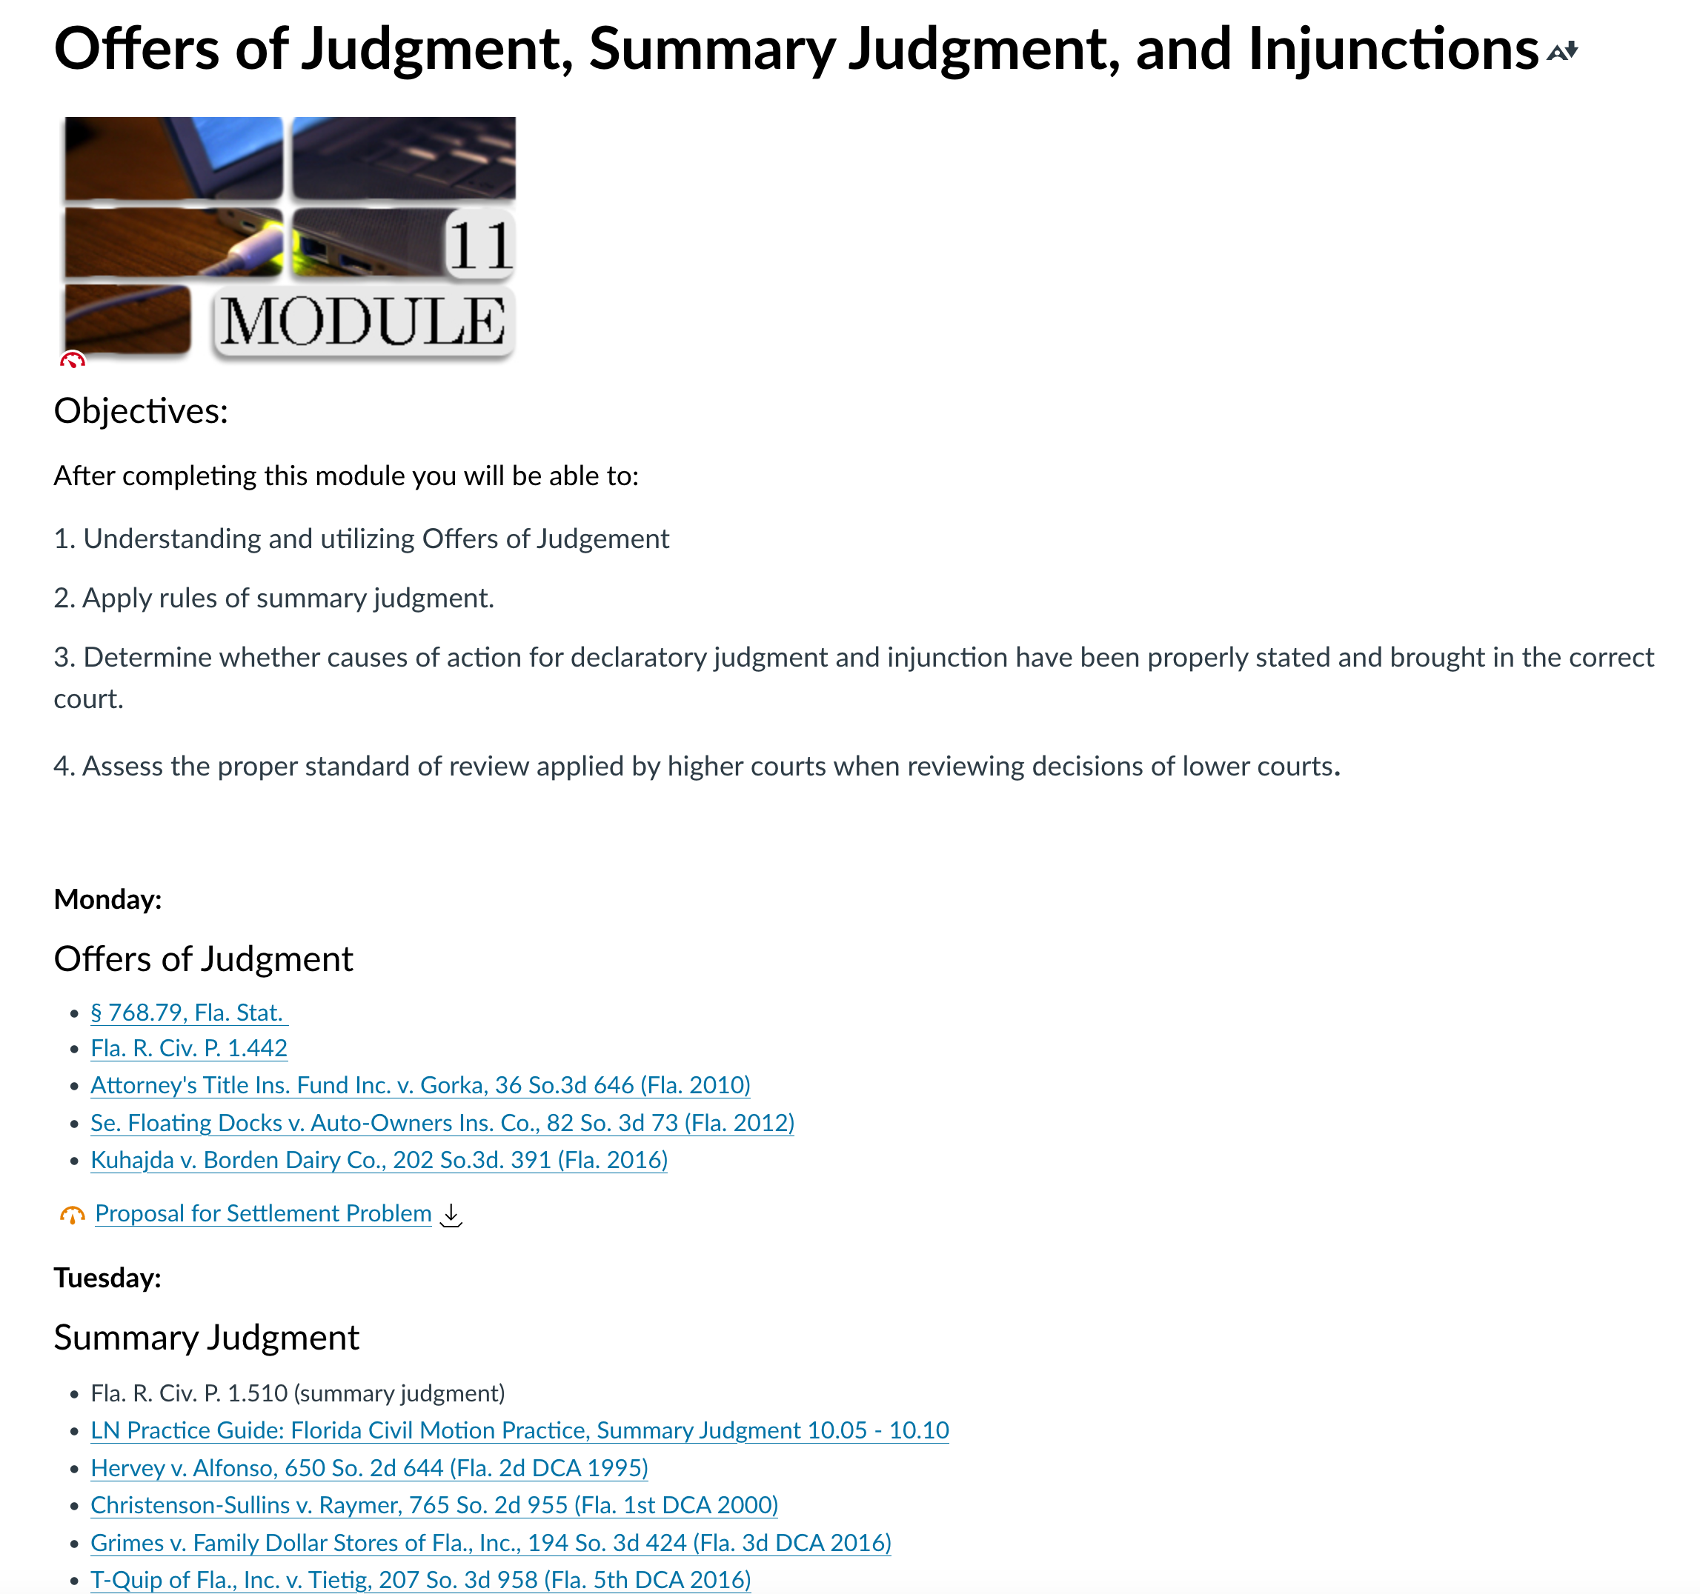

Week 12:
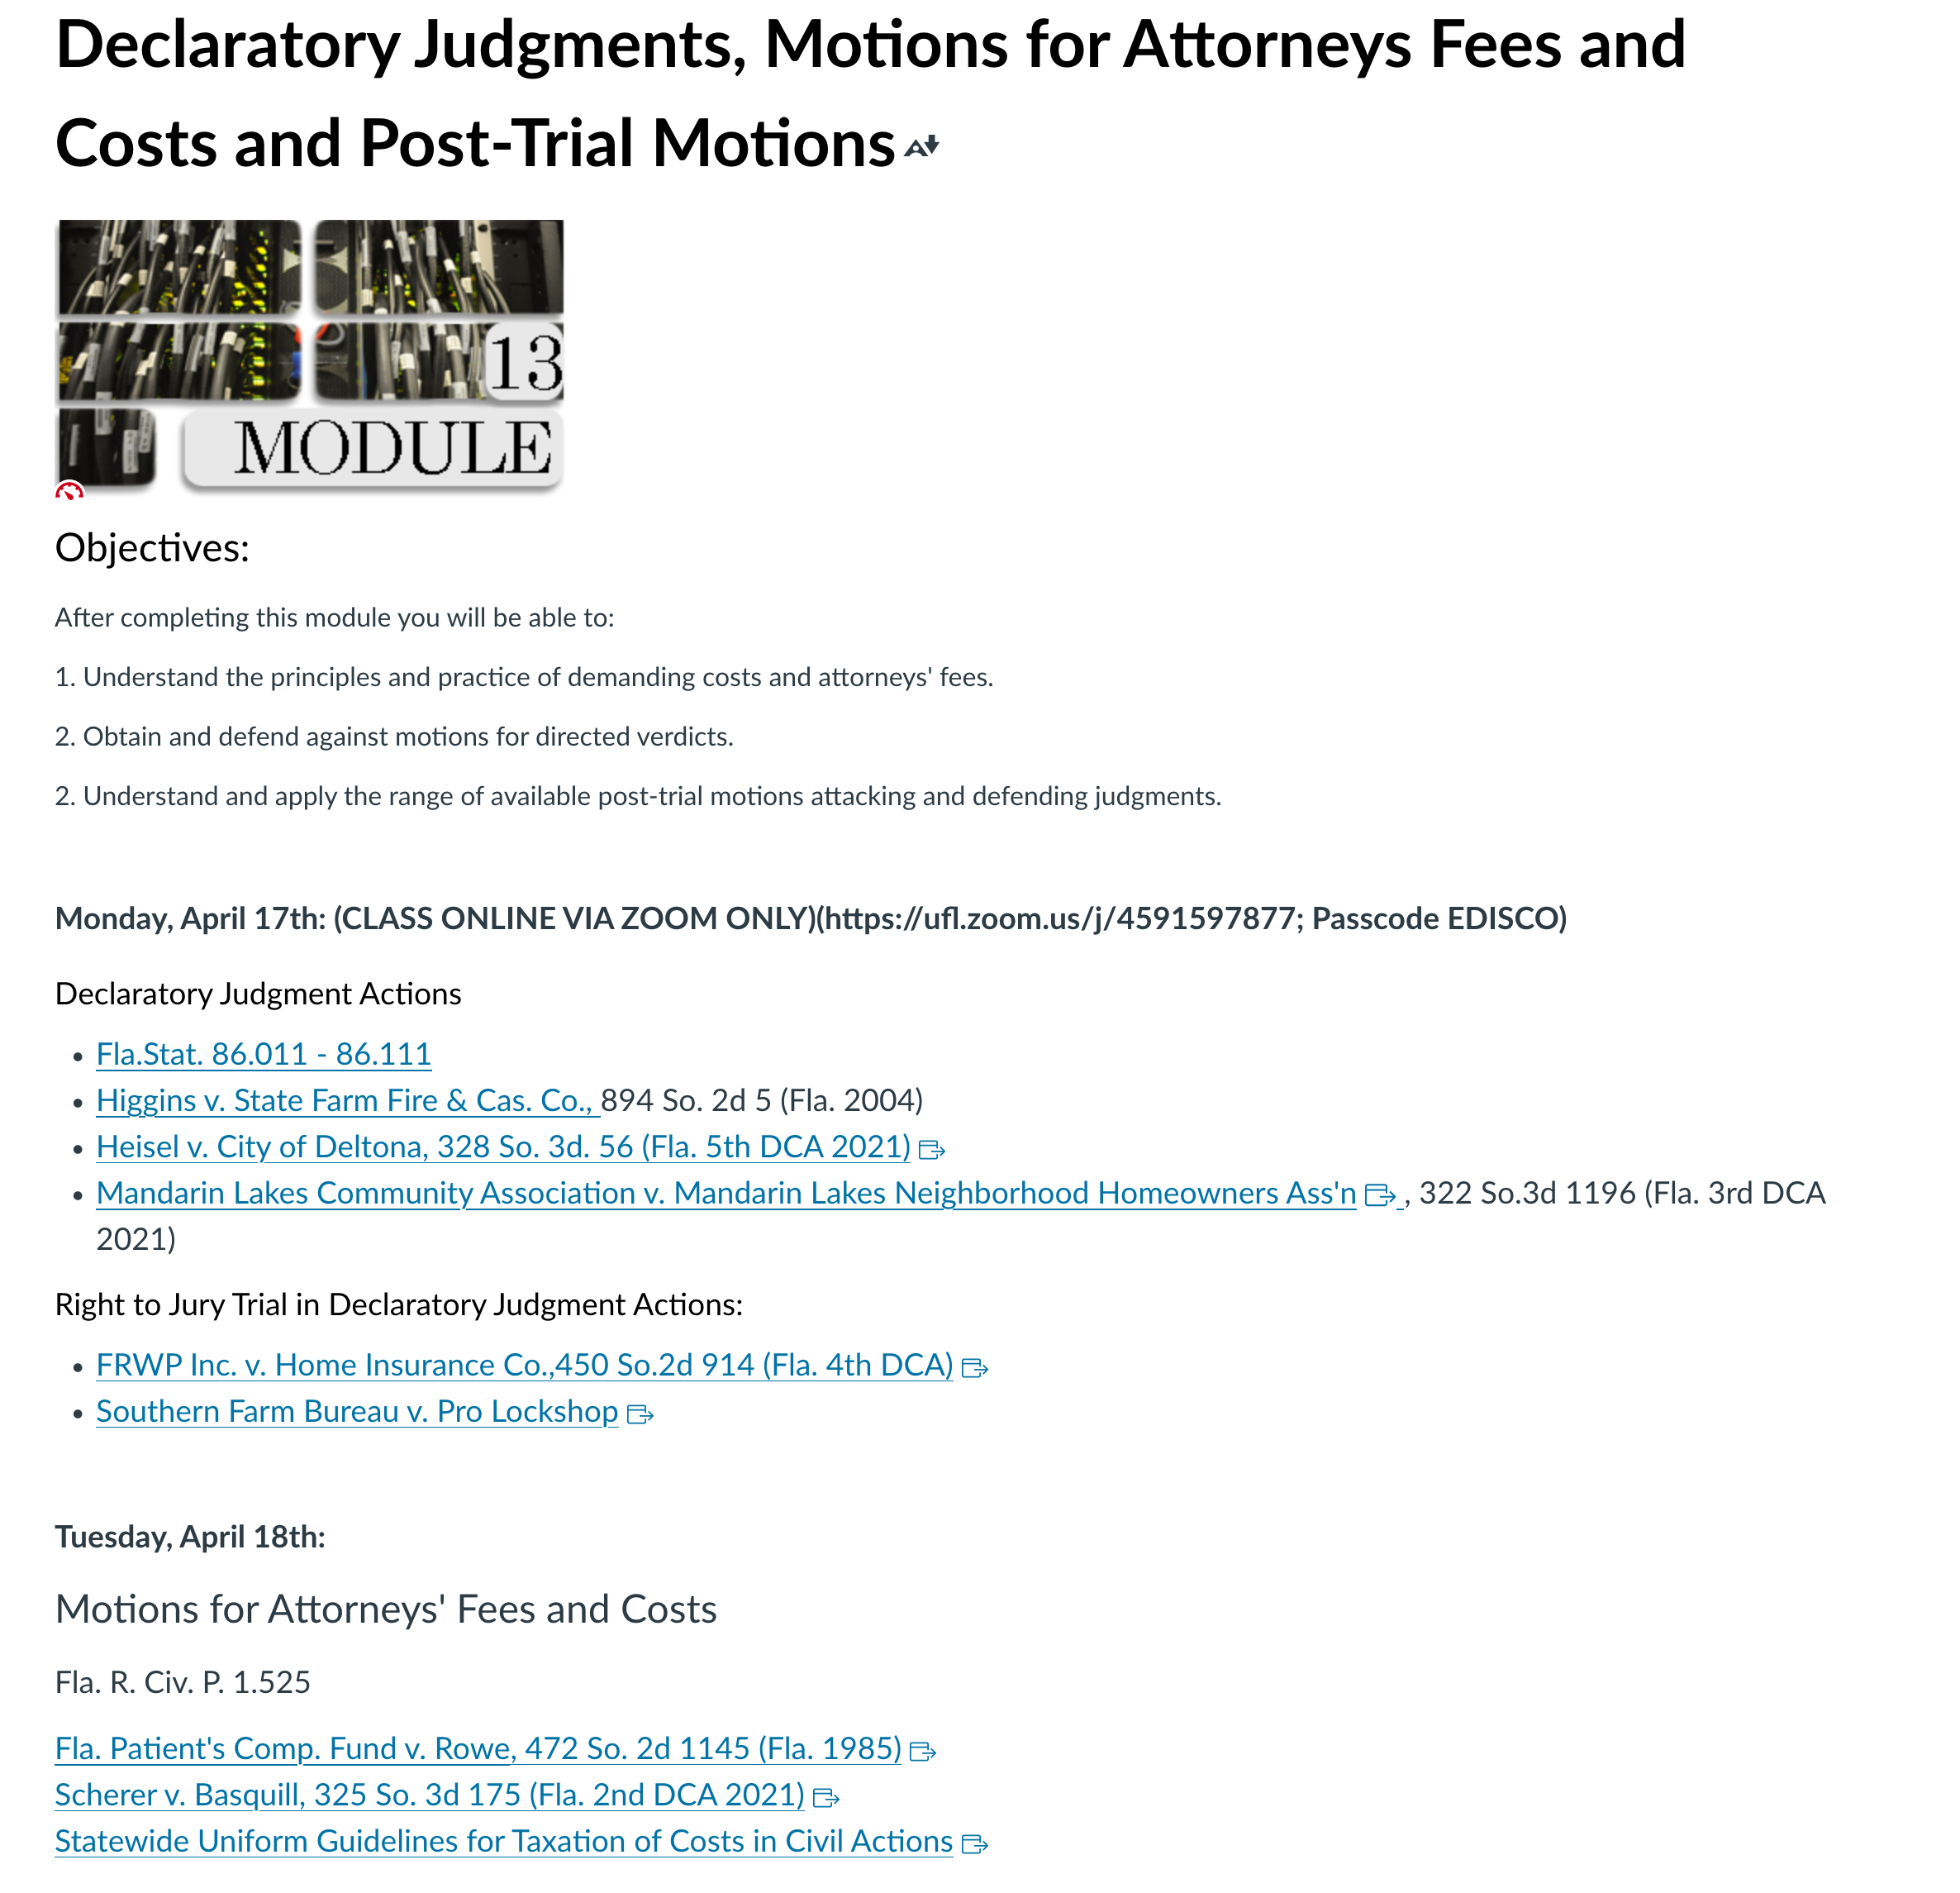

Week 13:
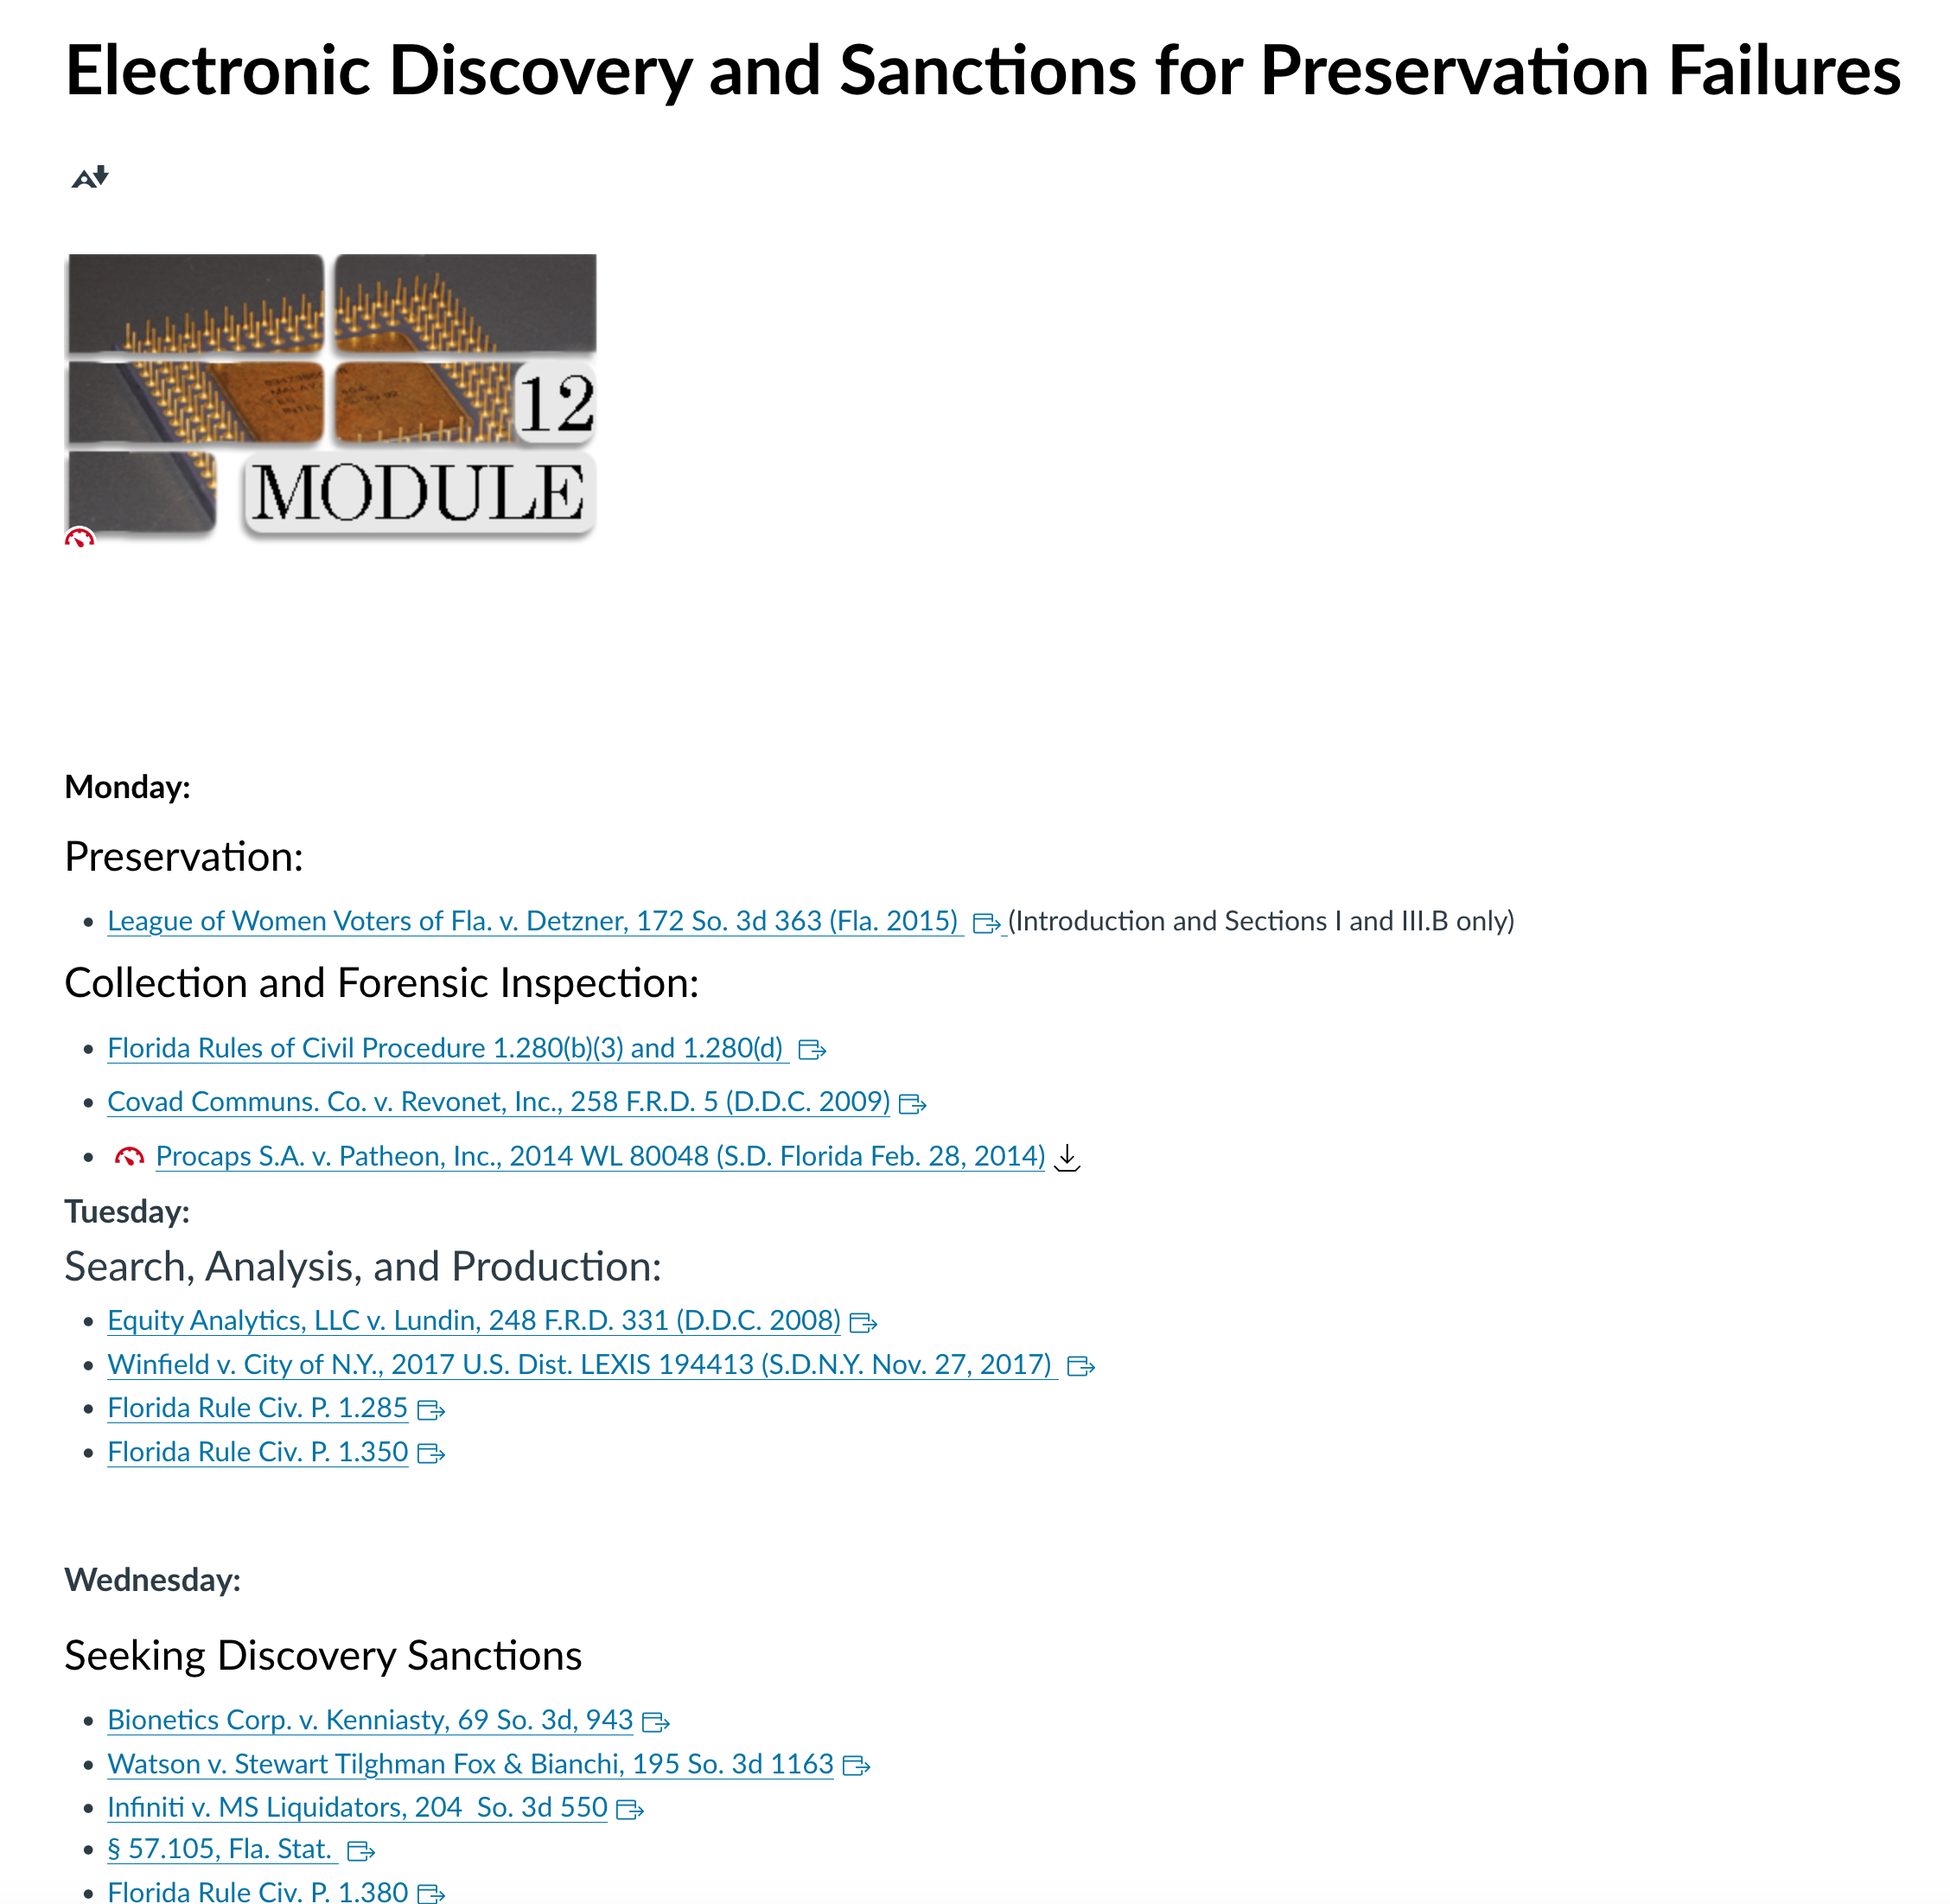

I reserve the right to make reasonable adjustments and modifications to the weekly schedule as required by the pace and progress of the class. The Canvas course website is your principal location for class assignments, events, and quizzes.

Workload/class preparation and the 2:1 out of class/in class requirement (ABA Standard 310) (multiple examples):

- Students should expect to spend, on average, approximately two hours preparing for every hour of class. Reading assignments are posted on the “Modules” link on the Canvas site (located on the left side of the Canvas site).
- It is anticipated that you will spend approximately 2 hours out of class reading and/or preparing for in class assignments for every 1 hour in class.
- ABA Standard 310 requires that students devote 120 minutes to out-of-class preparation for every “classroom hour” of in-class instruction. (Course) has 3 “classroom hours” of in-class instruction each week, requiring at least 6 hours of preparation outside of class. Accordingly, you will have about 60 pages of reading each week. Because the course includes statutory and regulatory excerpts that require careful reading, as well as discussion problems that require thoughtful advance written preparation, you should spend at least one hour on every 10-15 pages of reading.

Make-Up Examination, Quiz, and Assignment Policy:

The law school policy on exam delays and accommodations can be found here.

Statement related to accommodations for students with disabilities

Students requesting accommodation for disabilities must first register with the Dean of Students Office (http://www.dso.ufl.edu/drc/). The Dean of Students Office will provide documentation to the student who must then provide this documentation to me when requesting accommodation. You must submit this documentation prior to submitting assignments or taking the quizzes or exams. Accommodations are not retroactive, therefore, students should contact the office as soon as possible in the term for which they are seeking accommodations.

Information on UF Law grading policies

Grade Points Grade Point Grade Point
A (Excellent) 4.0 C+ 2.33 D- 0.67
A- 3.67 C (Satisfactory) 2.00 E (Failure) 0.0
B+ 3.33 C- 1.67
B (Good) 3.00 D+ 1.33
B- 2.67 D (Poor) 1.00

Student Course Evaluations
You can provide feedback on the quality of instruction in this course by completing online evaluations at https://evaluations.ufl.edu. Evaluations are typically open during the last two or three weeks of the semester, but you will receive notice of the specific times when they are open. Summary results of these assessments are available to students at https://evaluations.ufl.edu/results/

University policy on academic misconduct:
Academic honesty and integrity are fundamental values of the University community. You should be sure that they understand the UF Student Honor Code at http://www.dso.ufl.edu/students.php.

UF Levin College of Law Standard Syllabus Policiies:
Other information about UF Levin College of Law policies, including compliance with the UF Honor Code, Grading, Accommodations, Class Recordings, and Course Evaluations can be found at this link: https://ufl.instructure.com/courses/427635/files/74674656?wrap=1”

Getting help:
For issues with technical difficulties for E-learning in Canvas, please contact the UF Help Desk at:

● Learning-support@ufl.edu
● (352) 392-HELP - select option 2
● https://lss.at.ufl.edu/help.shtml

Other resources are available at http://www.distance.ufl.edu/getting-help for:
- Counseling and Wellness resources
- Disability resources
- Resources for handling student concerns and complaints
- Library Help Desk support

Disclaimer: This syllabus represents the current course plans and objectives. As the semester proceeds, these plans may be changed to enhance the class learning experience. Such changes, communicated clearly, are not unusual and should be expected.

